DATABASE SYSTEMS ENGINEERING AND DISTRIBUTED BACKEND DEVELOPMENT

TOPIC: PHYSICIAN & DEPARTMENT TABLES

2520030413 – CH. KAVYA SREE

STEP 1: CREATE PHYSICIAN TABLE:

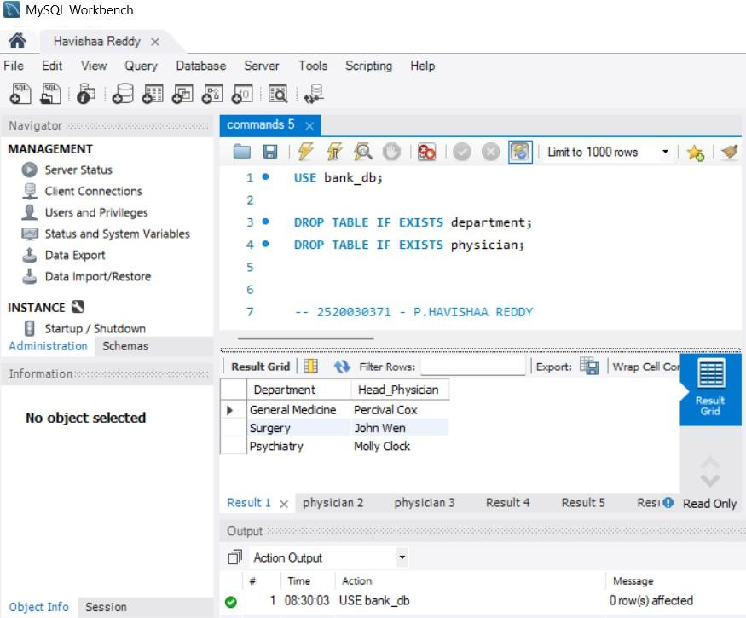

STEP 2: INSERT DATA INTO PHYSICIAN
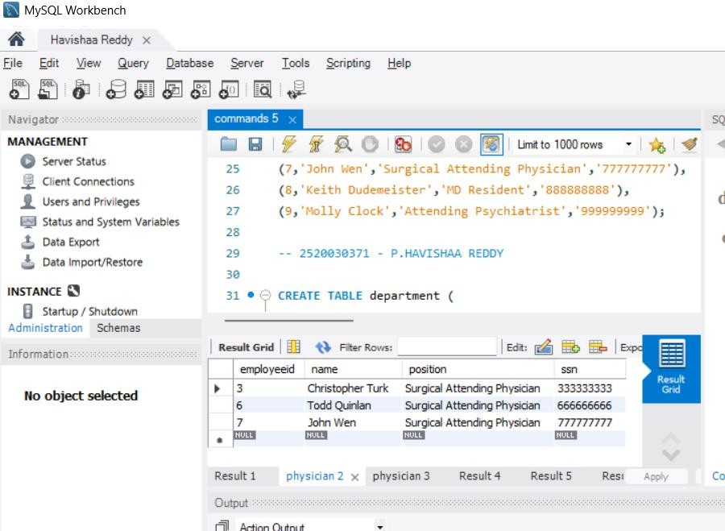

STEP 3: CREATE DEPARTMENT TABLE
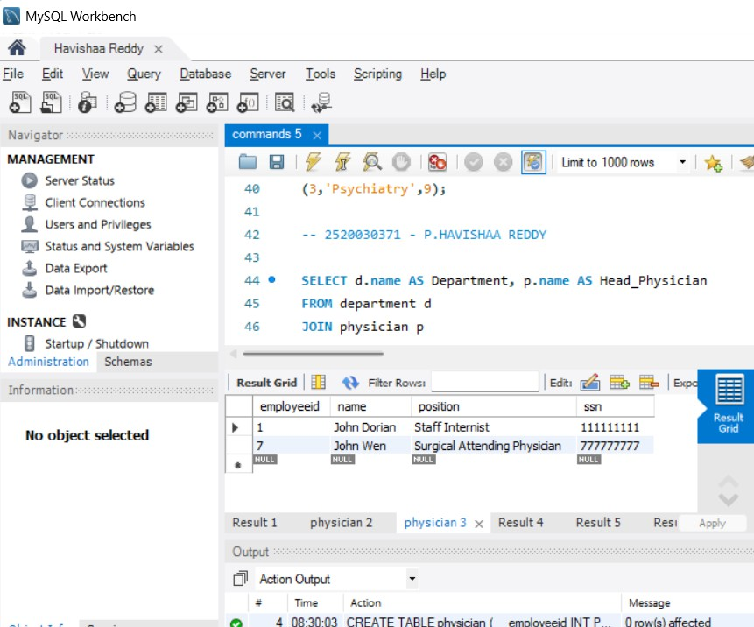

QUESTION 2 - WHERE CLAUSE

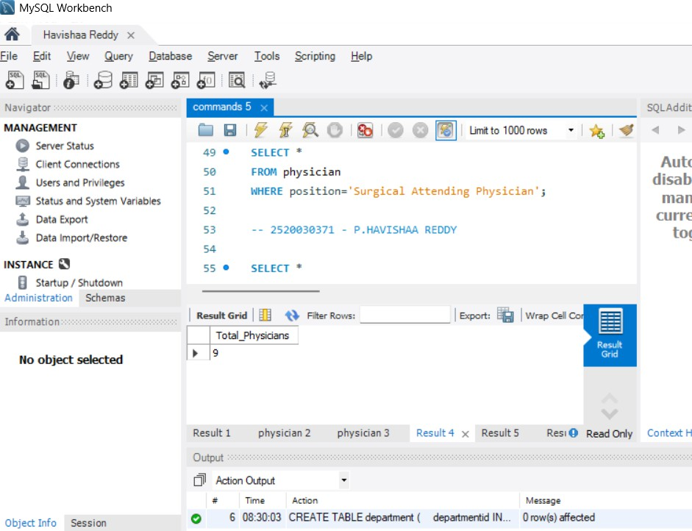

QUESTION 3 - WHERE + LIKE
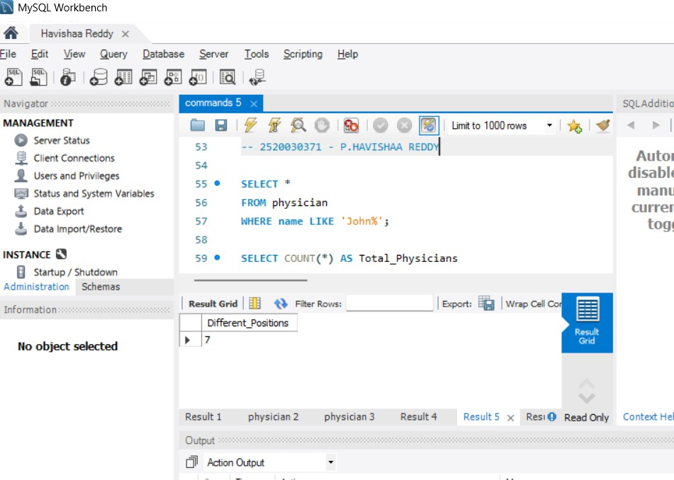

QUESTION 4 - COUNT()
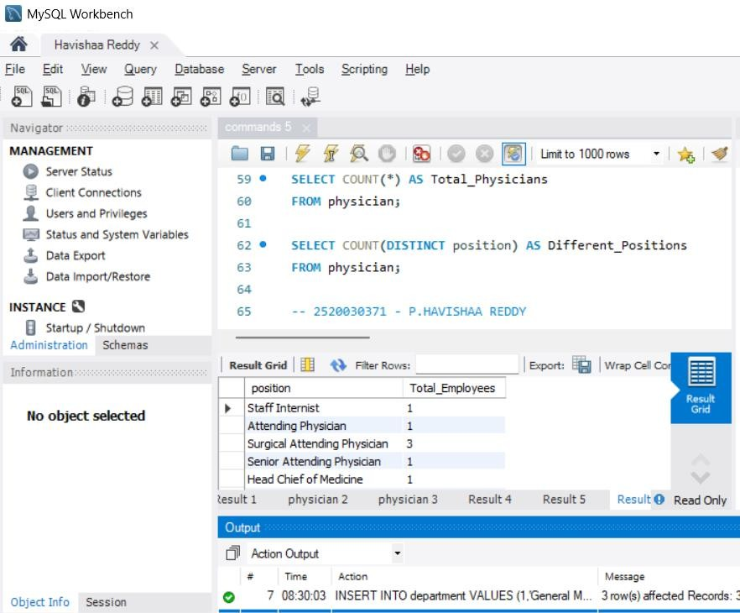

QUESTION 5 - COUNT DISTINCT
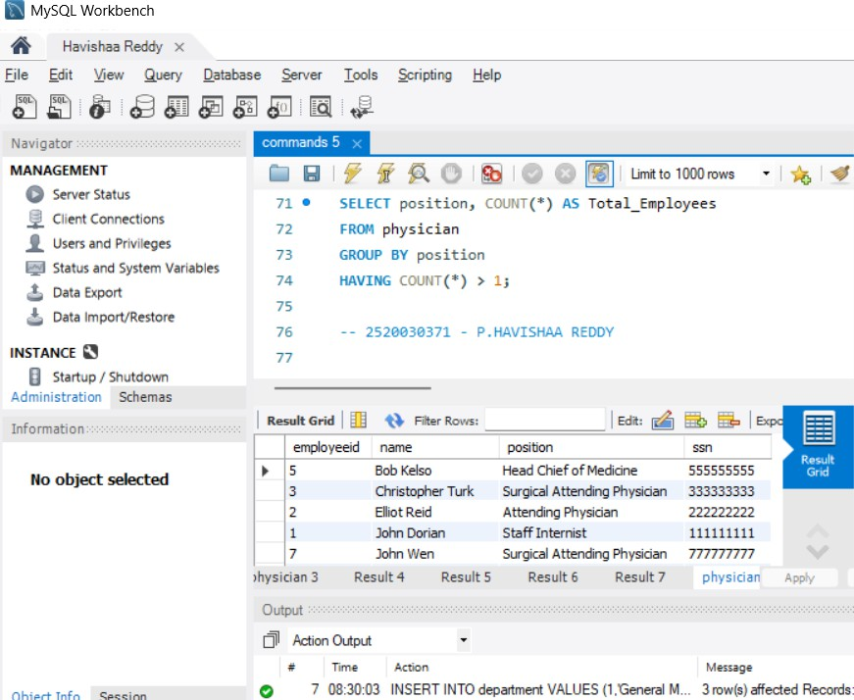

QUESTION 6 - GROUP BY
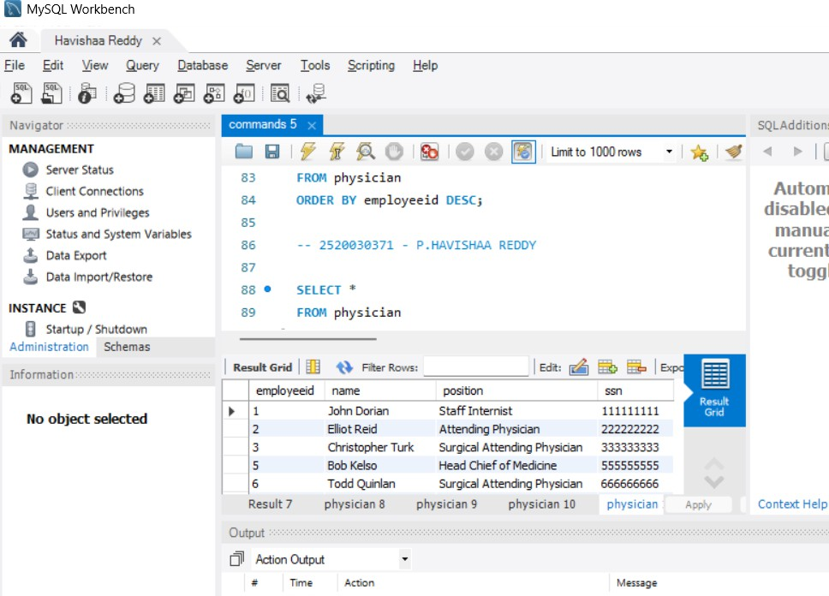

QUESTION - SUBQUERY
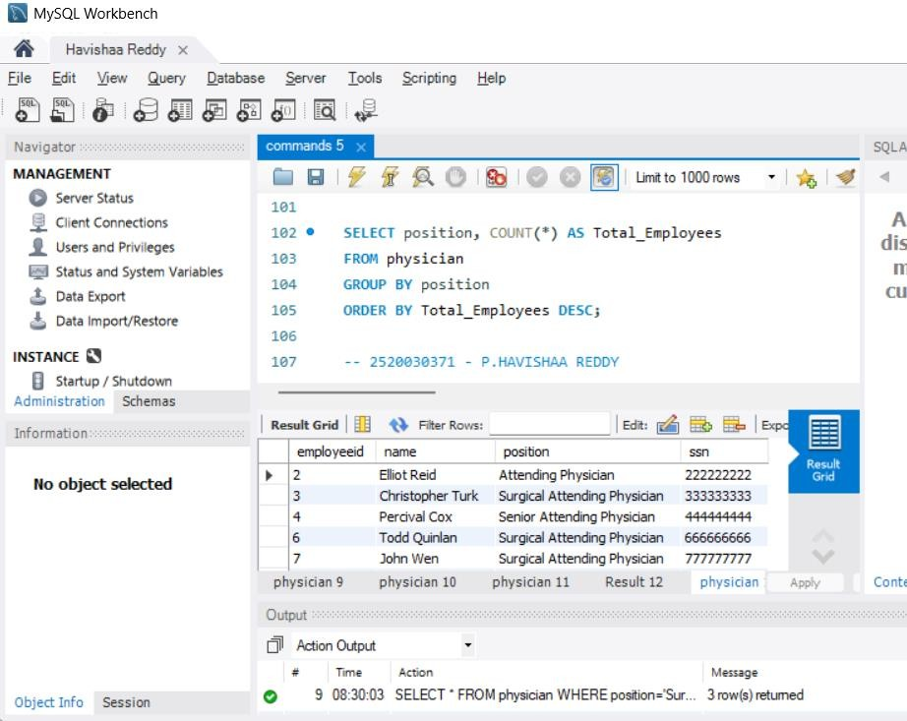
QUESTION - WHERE + LIKE
